Problem 1: Plot log10(x) for values from 1 to 1000
Source Code:
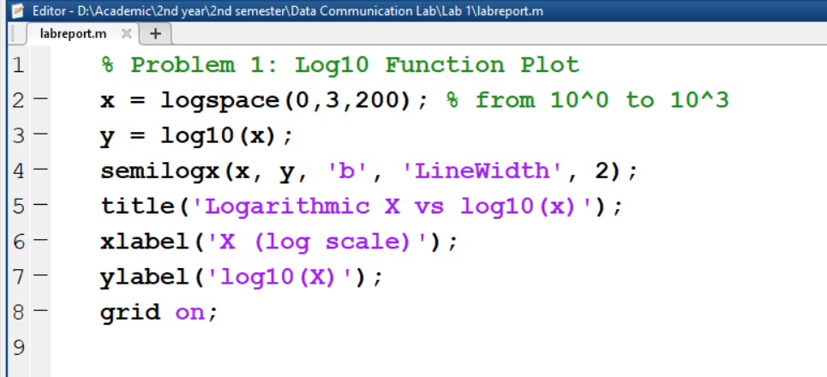
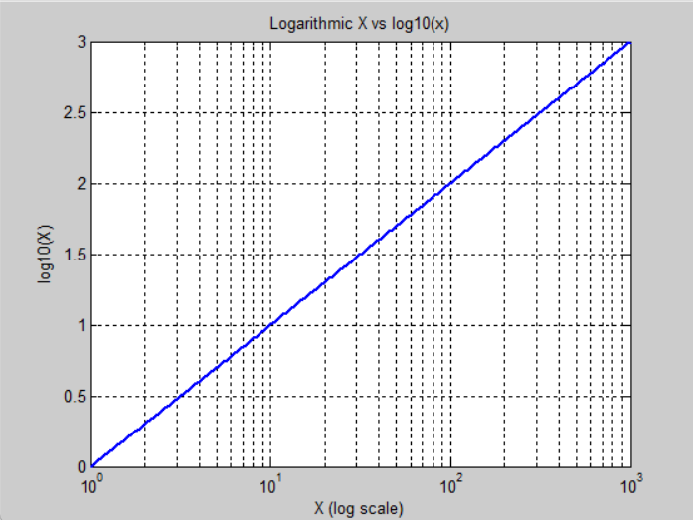
Problem 2: Compare log10(x) and ln(x) on the same plot
Source Code:
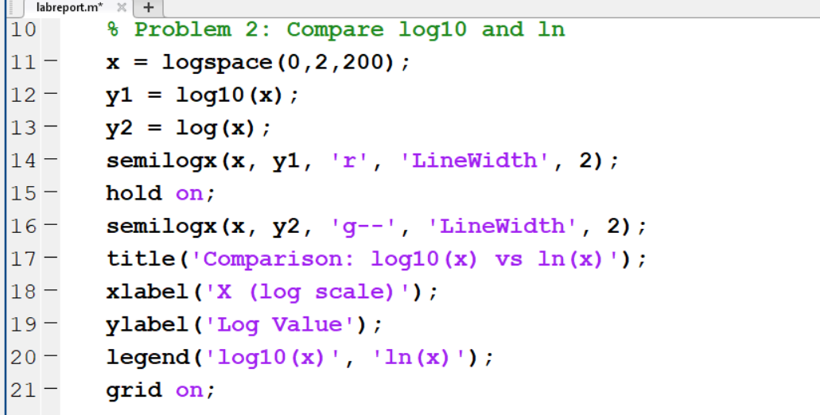
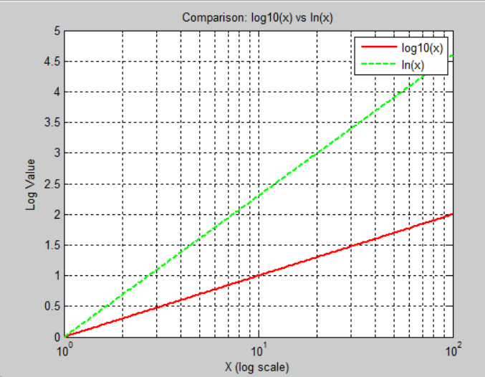

Problem 3: Area plot of sin(x) from 0 to 2π
Source Code:
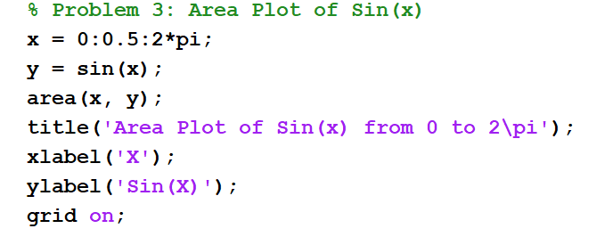
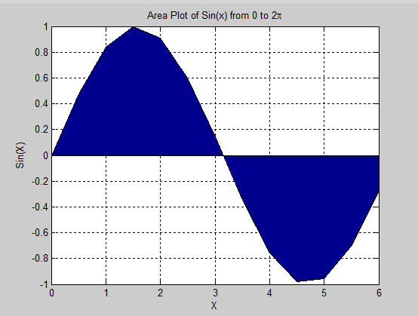

Problem 4: Area plot of sin(x) + 0.5*cos(2x)
Source Code:
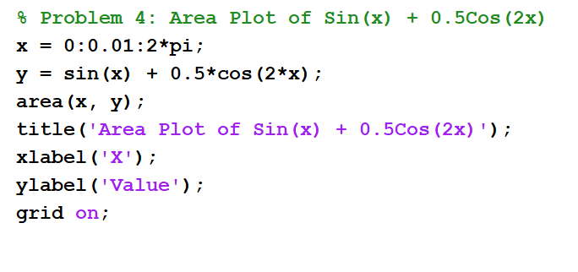
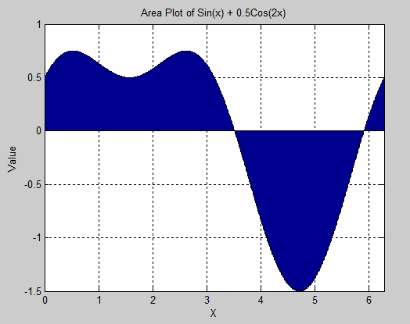

Problem 5: Plot sin(x) and sin(x + π/2) on the same graph
Source Code:
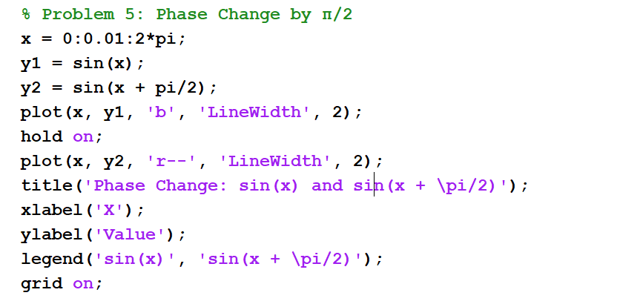
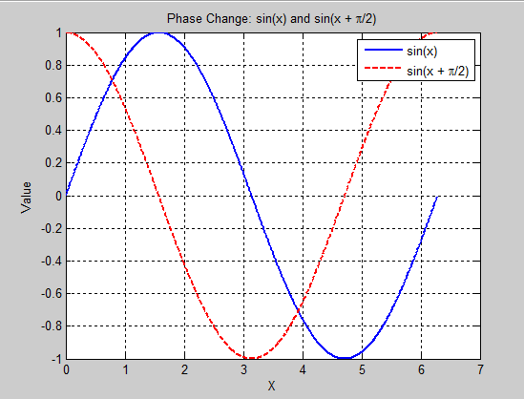

Problem 6: Show phase shift by π/4 in cosine wave
Source Code:
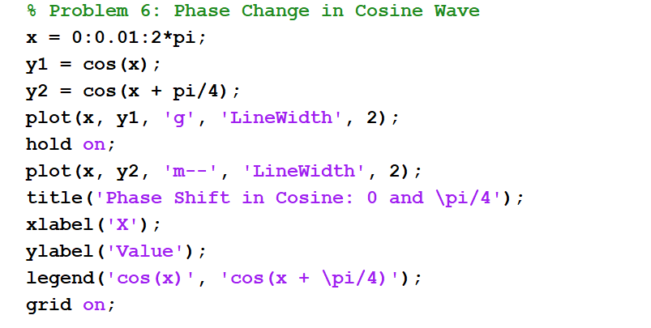
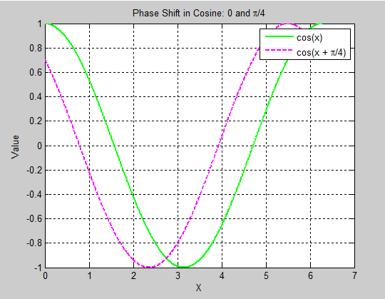

Problem 7: Compare sin(2πx) and sin(4πx)
Source Code:
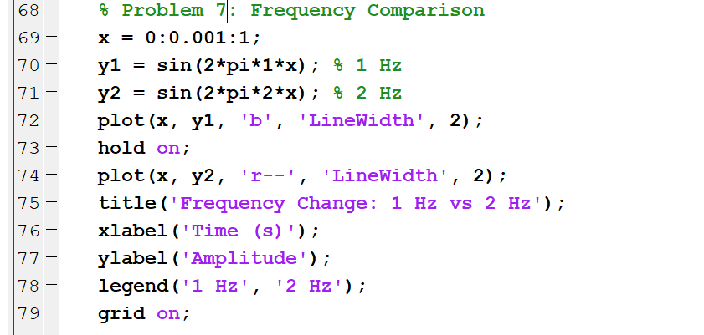
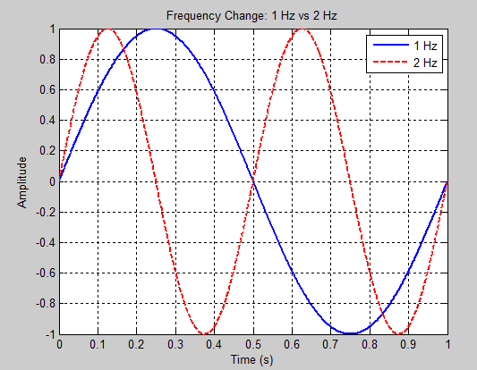

Problem 8: Show 5 Hz and 10 Hz cosine waves
Source Code:
